Project Report: Polyp Segmentation using U-Net
1. Introduction
Colorectal cancer is a leading cause of cancer-related mortality globally. Early detection of polyps during colonoscopy is critical for prevention. This project focuses on the development of a Deep Learning pipeline to automatically segment polyps from colonoscopy images. The solution is implemented in Python using the PyTorch framework, utilizing a U-Net architecture.
2. Data Acquisition
The dataset utilized is Kvasir-SEG, an open-access bio-medical dataset.
- Source: Simula Research Laboratory.
- Volume: 1,000 polyp images with corresponding ground-truth segmentation masks.
- Method: A custom Python script (download_data.py) automates the fetching and extraction of the dataset to ensure pipeline reproducibility.
3. Methodology: Data Preprocessing
A modular preprocessing pipeline was implemented in src/dataset.py to prepare the raw data for the neural network.
- Spatial Standardization: All images were resized to 128 x 128 pixels. This resolution was selected to optimize the trade-off between training speed (CPU efficiency) and segmentation accuracy.
- Normalization: RGB pixel values [0, 255] were scaled to the range [0, 1].
- Tensor Transformation: Data was converted to PyTorch tensors with the shape (Channels, Height, Width) for images and (1, Height, Width) for masks, adhering to the NCHW standard.
4. Methodology: Model Architecture
The project implements a U-Net, a fully convolutional network designed for biomedical image segmentation.
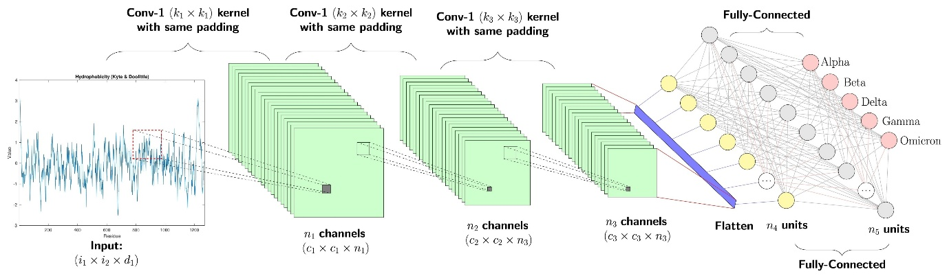
Shutterstock
- Encoder (Contracting Path): Consists of four blocks of Convolutional layers (ReLU activation, Batch Normalization) followed by Max Pooling. This extracts hierarchical features while reducing spatial dimensions.
- Bottleneck: The deepest layer connects the encoder and decoder, capturing high-level semantic context (512 feature channels) without spatial compression.
- Decoder (Expansive Path): Uses Transposed Convolutions to upsample the feature maps.
- Skip Connections: Concatenates features from the Encoder with the Decoder. This is the defining feature of U-Net, allowing the network to recover fine-grained spatial details (boundary information) lost during pooling.
- Output Layer: A 1 x 1 convolution with a Sigmoid activation function produces a probability map where each pixel value p [0, 1] represents the likelihood of being a polyp.
5. Training Strategy
The model training was orchestrated via train.py with the following configuration:
- Loss Function: Binary Cross-Entropy (BCE) Loss, suitable for pixel-wise binary classification tasks.
- Optimizer: Adam Optimizer with an initial learning rate of 1 x 10^{-4}.
- Batch Size: 16 (optimized for CPU processing with 128x128 images).
- Environment: The pipeline was deployed in a local Python virtual environment (venv) to ensure dependency isolation and reproducibility.
6. Implementation Challenges & Solutions
- SSL Verification: Automated data download scripts encountered SSL certificate errors due to strict network policies. This was resolved by implementing a robust request handler with SSL verification bypassing (verify=False) in download_data.py.
- Resource Optimization: To enable efficient training on standard CPU hardware without a dedicated GPU, the input resolution was adjusted to 128x128. This reduced the computational load per image by 75% compared to 256x256, allowing for rapid iteration and validation of the code logic.

